HOW TO GET TO

CAREY’S CAVE

THE ROAD TO WEE JASPER FROM CANBERRA

ROUTE 2: VIA URIARRA CROSSING
& MOUNTAIN CREEK RD

Distance: 72 km from John Gorton Drive
Road conditions: Mostly sealed.
2 km unsealed above Uriarra Crossing

Travelling time: Cotter Rd-WJ 75 mins

ROUTE 1: VIA YASS

Distance: Canberra CBD - Yass 60 km
Yass - Wee Jasper 52 km
Road conditions: All sealed road

Travelling time: Canberra - Yass 40 mins
Yass - Wee Jasper 50 mins
.

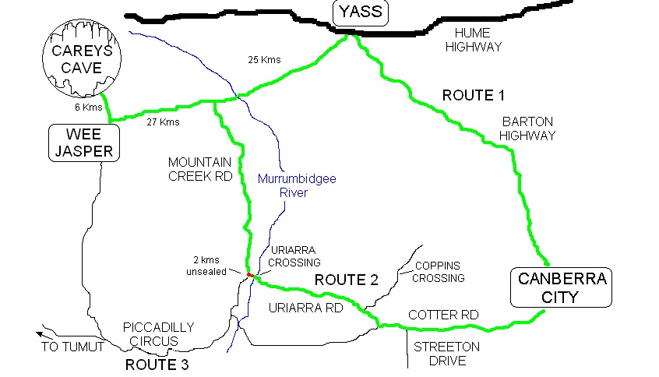

NB: Uriarra Rd is now accessed from the new John Gorton Drive which goes between Cotter Rd and Coppins Crossing.

ROUTE 3: VIA PICCADILLY CIRCUS
& BRINDABELLA VALLEY

Distance: 65 km
Road conditions: Unsealed. Some stretches rough. Caution required.
Travelling time: 2 hrs
Follow the brown sign at the traffic lights to Stromlo Forest Park and at second roundabout turn right.

PLEASE NOTE: Road conditions & travelling times will depend on weather and vehicle. Allow more time for coaches.

PAGE 1 OF 2

SUMMARY OF DIFFERENT ROUTES PAGE 2 OF 2

ROUTE 1:

This is probably the most convenient route if you are travelling from the north side of Canberra as it takes you along the Barton Highway, which runs through Murrumbateman to Yass.
The road from Yass to Wee Jasper travels through grazing country settled from the 1830’s on. Along this route lie a number of properties famous for their production of world-class fine wool, or their connections with newspapermen and members of royal families.
The descent to the Murrumbidgee River at Taemas Bridge affords a quite spectacular overview of the river flats and the outcropping of Devonian period limestone (the dark grey rock which appears in great looping bands on the far side of the river). This limestone is contemporary with that of the Wee Jasper valley.
About 5 km past Taemas Bridge you cross Mountain Creek where ROUTE 2 joins the road to Wee Jasper.

ROUTE 2:
This is the quickest route if you are travelling from the western or southern side of Canberra. Note changes to main roads here:
Drive north from Cotter Rd at end of Streeton Drive on new John Gorton Drive. Turn left at brown sign for Stromlo Forest Park. Go to 2nd roundabout , turn right onto Uriarra Rd and follow this to the Murrumbidgee River at Uriarra crossing. [You can also connect from Belconnen area by going down over Coppins crossing and turning right at brown Stromlo Forest Park sign].
Cross the river and turn right up the hill until you reach Mountain Creek Rd. Don’t be discouraged by the bit of unsealed road as it doesn’t last for long. Turn right onto Mountain Creek Rd and follow it all the way till you meet the Yass-WJ road and turn left.

BOTH ROUTES: You then follow this road all the way to Wee Jasper. There are some marvelous views over the valley as you descend to Wee Jasper, but please take care winding down the curves and stay on your own side of the road! The way to Carey’s Cave is well sign posted from the village, driving through impressive belts of limestone, but remember the land bounding the road is privately owned.

ROUTE 3:
For those feeling more adventurous, particularly if you have a 4WD, this route takes you through the Brindabella valley heading towards Tumut, but if you miss the Wee Jasper turn you may travel much further (and longer) than planned. The turn is not signposted. (When I have a distance from the bridge over the Goodradigbee River I will include it in
this information.) You will eventually enter the southern end of the Wee Jasper valley at Micalong Creek campground and travel the length of the valley to the village.

The WEE JASPER VALLEY brochure is available from Canberra and Yass Visitor Information Centres. This contains a detailed map and information about what accommodation and services are available in the valley.
.
FOR MORE INFORMATION PHONE CAREY’S CAVE on (02) 6227 9622

OR CHECK OUR WEBSITE: www.weejaspercaves.com

